Mammal Damage
Medium priority
Hare AH | Vole AV
Moose AM | Deer AD
Porcupine AP | Cattle AC
Squirrel AS | Black Bear AB

Description

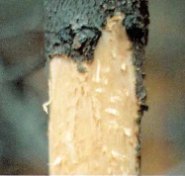
All tree species are susceptible to hare damage. Seedlings are cut in an oblique, knife-like manner and the lateral or terminal shoots are removed. Bark is gnawed in small patches near the base of the stem or on the lower branches. Feeding damage may occur higher on the tree, depending on snow depth. The stem is occasionally girdled. High-risk stands occur in areas between clearcuts with young seedlings, and high-density, second growth, pole-size pine stands with a dense brushy understory. Newly planted seedlings or trees that have recently been fertilized are most attractive. Smaller seedlings are highly susceptible to mortality from clipping at the root collar. Larger seedlings suffer deformity, reduced growth rate, and occasional mortality. Young lodgepole pine, not covered by snow, are very susceptible to damage. Most damage occurs within several years of planting and follows a very regular 9 to 11-year population cycle.

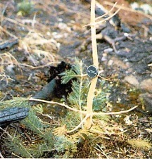
Voles clip the terminal and lateral shoots of small seedlings, leaving a rough, oblique cut. Larger seedlings and saplings are debarked and often girdled. Locations where voles are a problem are clearcuts with lush, grassy-brushy vegetation, near a water source. Most damage occurs during very high population densities (every 3 to 4 years) over the winter and can be extensive in some plantations. Winter feeding usually takes place under the snow in the interior. Small seedlings have reduced growth or are killed as a result of clipping. Growth rates of larger seedlings and saplings can also be adversely affected by feeding activities on the roots, root collar, lower stem, and lower branches. Girdling of these trees causes scattered mortality. Heavy losses can occur in black cottonwood and hybrid poplar plantations. Voles create the largest potential impediment to plantation establishment for native cottonwoods and hybrid poplars. Vole damage can occur on trees 10 to 12 m tall.
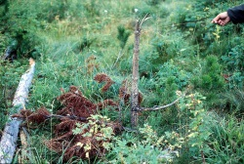
Browsing, trampling, pulling, and rubbing are all physical injuries that may be caused by cattle. Damage is more likely and more severe if the livestock are confined to a small area, or if they do not have access to abundant and palatable forage. The tender new growth of ponderosa and lodgepole pine may be browsed even when sufficient fodder is available.

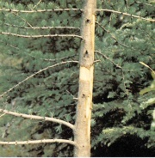
Porcupine attacks on conifers can cause serious losses. Scattered mortality can occur over fairly extensive areas. Trees die when the lower portion of the stem is girdled. Annual mortality rates are estimated to be about 1% per year of the hemlock and spruce component in heavily damaged stands. Top kill, deformity, and reduced growth rate result from feeding activities on the upper stem and in the crown.

Extent
Currently mammal damage is a moderate priority forest health factor. Vole and hare populations and the potential damage their feeding can cause are highly cyclical. At this time, it is believed that the hare population is on the increase. The reforestation of Dothistroma and MPB affected stands has been hindered due to prime habitat conditions for vole and hare – notably the increased cover which provide a protection from predators, and the increased herbaceous growth as a food source. Frank Doyle is currently conducting research on this issue.
Data
- See map attached at the end of the section

Tactics
- Incidence levels should continue to be monitored and their priority reassessed at the annual review stage.
- If there is a known risk then the time of planting and stock size should be adjusted accordingly.
- In areas of increasing hare populations, it is important to be aware that planting under canopies generally leads to greater hare damage due to limited predator access. The Forests For Tommorow program experienced problems with hare browse when underplanting below MPB killed stands. It was generally found that the preferred treatment was to remove the dead overstorey prior to reforesting the site. The Dothistroma reforestation program has trials in place testing the value of seedling protectors and various stock sizes to mitigate hare browsing. Refer to Skeena Stikine FD for a copy of the research report 2009 Annual Report: Mitigating the impacts of Snowshoe Hare browse damage on underplanted seedling trees in Dothistroma infested pine stands.
- Refer to Appendix for a chart outlining the Factors impacting the risk of damage and mortality to unprotected seedlings by snowshoe hares in north central BC

Underplanted SX Trials
In April 2010 the key messages supplied through Frank Doyle’s research were:
- The high understorey herb-shrub growth that is evident in Dothistroma and MPB attacked stands has created ideal hare habitat.
- When planting trials were initiated, at what we now know was the decline in hare numbers, up to 70% of underplanted spruce seedlings were browsed.
- New growth is now clearly evident, on any seedlings that survived the last hare peak.
- Assuming the hare population trend fits with other monitored northern hare populations, we will see a dramatic increase in hare numbers over the next few years, and a comparable increase in damage /mortality to seedlings trees.
- Predictably, sites with low understorey cover (<30% cover, >0.5m high) have the lowest rates of hare browse damage on seedlings.
Ongoing questions -as hare populations increase:
- For unprotected seedlings will the new growth be subsequently browsed?
- Within the SX Trials, how effective will the tree shelters and other planting strategies be at mitigating future high rates of hare browsing?
- Which strategy will ultimately result in acceptable (and cost effective) stocking standards in underplanted Doth and MPB stands?
- Will we see comparable high rates of seedling browse in both underplanted, and harvested Doth (MPB) stands as a result of the now established high understorey herb-shrub cover?

